LESSON PLAN COVER SHEET
Module 7B
COURSE TITLE: Perpetrator Realities and Alcohol and Drug Facilitated Sexual Assault Cases |  | TIME: 2 hours of instruction with slides from Module 6 and a 15-minute break
DATE INSTRUCTOR PREPARED: | DATE INSTRUCTOR REVISED:
INSTRUCTOR: For this module, the instructor should:  - Have an understanding of the neurobiology of trauma and how it impacts victim behavior, actions, and memory.  - Have experience in training law enforcement and basic understanding of sexual assault, and the possible co-occurring crimes such as domestic violence, stalking, and strangulation.  - Have credibility gained through their own experience investigating these crimes as a law enforcement officer.  - Have experience conducting suspect interviews. |  |  | TRAINING AIDS, EQUIPMENT, MATERIALS:  - LCD Projector and Computer  - Projector Screen  - Easel and Chart Pads or Whiteboard  - Markers and Tape
COURSE DESCRIPTION: In this section, the focus is to explore the realities of perpetrator behavior and provide background on the characteristics of alcohol and drug facilitated sexual assault as well as provide strategies for investigating these types of cases.

Note that slides 3-10 are the same as those slides in Module 6; Module 7B is to be used if you did not recently conduct Module 6 with the same training participants.

INSTRUCTOR PREPARATION: Read and watch all included instructor references and supplemental content. Due to the complex nature of sexual assault crimes involving drugs and/or alcohol, it is crucial to understand the context of the material in this guide in order to facilitate this training block and respond to participant questions.

Read all PowerPoints slides and Lesson Plan. Add and tailor content to include relevant state and local laws, agency policies, and your own case examples.
INSTRUCTOR REFERENCES:  - Sexual Assault Response Policy and Training Content Guidelines, IACP  - Sexual Assault Incident Reports, IACP  - Rachel Lovell, Fred Butcher, and Daniel Flannery, Cuyahoga County Sexual Assault Kit Pilot Project (SAK)  - EVAWI “Empathy-Based Suspect Interviewing Webinars”:  Part 1 & Part 2  - EVAWI “Challenging Victims: The Delicate Dynamics of Drug & Alcohol Facilitated Sexual Assault Webinar”  - EVAWI “A Dangerous Defense: “Blackout” in Alcohol Facilitated, Non-Stranger Sexual Assault Cases Webinar”  - National Sexual Violence Resource Center, “SART Toolkit Section 5.5”  - Sexual Assault Forensic Examiner TA: “Examination Process - Alcohol and Drug Facilitated Sexual Assault”  - AEquitas, “Alcohol- and Drug-Facilitated Sexual Assault: A Survey of the Law” (specifically read information on your state’s statute)  - AEquitas “Alcohol-Facilitated Sexual Assault Webinars”: Part 1 & Part 2  - Fanelli, “IACP Drug and Alcohol Facilitated Sexual Assault Webinar” |  |  | METHOD OF INSTRUCTION:  - Facilitated discussion  - Information Briefs  - Activities  - Case Study Examples
At the completion of this lesson, participants will be able to:

- Identify common perpetrator dynamics and behaviors.
- Describe how perpetrators use alcohol and drugs as a weapon to facilitate committing sexual assaults by increasing victim vulnerability and decreasing credibility.
- Explain common perpetrator defense strategies.
- Identify strategies for trauma-informed investigation of alcohol and drug facilitated sexual assault cases.

Perpetrator Realities and Alcohol and Drug Facilitated Sexual Assault Cases

Content | Slides
Introduction  This module will provide background on the characteristics and complexities of alcohol and drug facilitated sexual assault as well as provide strategies for investigating these types of cases.  Discuss objectives on slide. Emphasize that perpetrators employ tactics to create vulnerability and decrease credibility to include pre-existing relationships, power imbalances, coercion, and threats.  As we have discussed in previous modules, the hormone tsunami from a traumatic event may make a victim feel as if they were drugged without the presence of any substances. This is important to remember because even if there is no evidence of drugs or alcohol, the neurobiology of trauma could cause similar feelings and behaviors in the victim, leading them to believe they were drugged.  Also, as we have discussed in previous modules, a traumatic experience like sexual assault affects how memories are encoded and stored. Adding incapacitating substances like alcohol and drugs can further impact a victim’s memory. Therefore, it is important for law enforcement and others in the criminal justice system to understand the impacts of alcohol and drugs on victims as well as the tactics perpetrators use to commit sexual assault; combined with trauma-informed and perpetrator-focused investigative strategies in these cases, investigators can thoroughly examine the context and present an accurate case.  Module 6 – Perpetrator Realities Slides  Society holds the stereotype—and myth—that most sexual assault perpetrators are violent strangers who are monsters and clearly identifiable as predators. As such, society’s image of a “typical” sexual assault is something like a stranger jumping out of the bushes or a sketchy van at night to assault someone. As we have previously discussed, society also holds stereotypes and myths about how victims “should” act, though we know there is no single way trauma manifests in victims and no “normal” way for victims to react to sexual assault.  These images of a perpetrator and a “typical” sexual assault are spread and reinforced by the media because they make for more effective drama. And since they meet our expectations and confirm our stereotypes, we are more likely to believe them. This narrative also gives society a false sense of security, because if we know how to identify the perpetrator, we believe we know how to avoid them and the circumstances under which sexual assault happens (to other people).  This narrative also contributes to a focus on victims preventing their own assault from happening rather than putting the responsibility on individuals not to assault others, which is where the focus should be. Prevention tactics might be successful in certain circumstances, but sexual assault is often committed by someone known to the victim who exploits the relationship and will not prevent the perpetrator from assaulting someone else.  These stereotypes/myths make us less inclined to believe sexual assault cases or victims who do not match what we believe a “typical” assault or victim are like.  As mentioned in “Module 1 – Overcoming the Complexities of Sexual Violence: Understanding the Realities,” the reality is that many perpetrators:  - Are strategic and opportunistic in that they prey on individuals who are vulnerable, are accessible, and have a perceived lack of credibility. Perpetrators may go into a situation planning to offend, or they may exploit an opportunity that they choose to take advantage of in the moment. They also use tactics to increase the vulnerability of potential victims.  - Are known to the victim, even if only for a brief time.  - Are repeat offenders who have offended against multiple victims. In a 2016 study, “Cuyahoga County Sexual Assault Kit Pilot Project,” the Begun Center found that 51% of Cuyahoga County sexual assault kits were connected to serial perpetrators.  - Only use instrumental violence, meaning the amount of force, threat, intimidation, or violence necessary to subdue or coerce the victim. They might not use additional physical violence beyond the rape or sexual assault.  - Remind participants to think about the law enforcement use-of-force continuum; officers use only the amount of force necessary to get the suspect to comply.  - Have a history of or also engage in other violent crimes in addition to sexual assault.  Remember that the perpetrators choose to victimize; victims do not choose to be victimized.  Prep Work: Insert current statistics from sakitta.org/metrics and explain the current statistics and research showing that perpetrators who raped a known partner/acquaintance are also likely to have raped a stranger.  - 2016 study, Cuyahoga County Sexual Assault Kit Pilot Project, by Begun Center found that 33.3% of perpetrators assaulted strangers and people known to them (casual/recent acquaintance or former/current intimate partner).  Prep Work: Insert current statistics from Centers for Disease Control and Prevention regarding sexual violence within intimate partner relationships and explain that domestic violence perpetrators also often commit sexual violence (Centers for Disease Control and Prevention)  - The National Intimate Partner and Sexual Violence Survey: 2015 Data Brief found that 18.3% of women and 8.2% of men had experienced contact sexual violence perpetrated by an intimate partner.  Explain that research also shows that perpetrators tend to have common characteristics and discuss each of the six listed on the slide. Perpetrators are opportunists and tend to target individuals who are already vulnerable, accessible, and perceived by others in society as less credible. In addition, they also actively strategize to increase their victims’ vulnerability, accessibility, and perceived lack of credibility to make them easier to victimize, less likely to be believed, and to make it more likely that the perpetrator will not face consequences.  Vulnerability – victim characteristics that make them an “easier target,” which can include factors such as a power differential between the victim and perpetrator, or the victim’s lifestyle, age, disability, addiction, and physical and mental disorders.  Accessibility – how difficult it is for the perpetrator to access and isolate the victim, this could include someone who is at the same bar on any given night, a student in a class they teach, or someone on a sports team they coach. Targeting a victim for their accessibility could include the victim’s location—if they live or work alone or are walking on a quiet street—and a lack of witnesses.  Perceived credibility – society’s perception of how much to believe a victim, which is influenced by victim characteristics such as race, class, age, sexual orientation, gender, gender-identity, and lifestyle choices, particularly if they engage in illegal behavior. These characteristics often overlap, and accessibility and perceived lack of credibility also increase a potential victim’s vulnerability.  In addition, perpetrators who are seen as extremely credible in society are more easily able to convince society that their victim is less credible; for example clergy, teachers, sports/music icons, celebrities, doctors, law enforcement, wealthy individuals, and others who are held in high regard in the community.  There are many more examples of types of individuals who perpetrators target. Perpetrators target individuals who they perceive as vulnerable due to physical, mental, and/or other characteristics that they already have, and perpetrators also seek to increase these vulnerabilities. For instance, perpetrators often target individuals who have physical or mental disabilities; have mental health issues; have a history of trauma; are elderly; are homeless; engage in sex work; are under the influence of drugs/alcohol; and/or are from marginalized populations (for example, individuals who are LGBTQ+, women of color, and/or have limited English proficiency).  Perpetrators target these individuals because they believe they are more vulnerable, less likely to report to the police, and less likely to be believed at all points in the criminal justice system if they do report. We discussed many of these societal misconceptions and biases in “Module 2: How Does Culture Influence the Communities We Serve?”—how these individuals are less likely to be believed by others (family, friends, community members) and the criminal justice system, making it less likely that the perpetrator will face consequences.  Perpetrators also actively seek to increase any existing vulnerabilities and create new ones, increase accessibility, and work to further undermine victim credibility using the following tactics:  - Targeting – Identifying a potential victim and directing efforts at that individual.  - Grooming / Organizing – Planning, pre-meditation, and gaining the victim’s trust prior to abuse; this is often first convincing the victim and others to see them as a “good Samaritan” or “nice guy,” and then escalating behaviors slowly to convince the victim it is all normal.  - Tell participants to think about child sexual assault investigations and behaviors that suspects use in these cases to “groom” the victim. Ask participants to share a few, such as:  - Forming friendship with victim and with victim’s family/friends  - Isolating the victim  - Testing – Testing and pushing the victim’s boundaries to gauge their reaction; for instance, by placing a hand on the victim’s arm and seeing if they move away, and then escalating these behaviors.  - Manipulation – Trying to convince the victim they love and care about them, or that the perpetrator’s behavior is the victim’s fault, for example that the victim “led them on.”  - Isolating – Separating the victim from their friends and family, from a group they are with, or potential witnesses to make them accessible.  - Coercion – This is often the use of intimidation and threats; the use of or persisting and not accepting “no” as an answer, instead continuing to “ask”; or rarely, a weapon.  - Prep Work: Look at your state statute for how coercion is defined and what elements are necessary for it to be considered as part of a sexual assault crime. Recognize that the community definition of coercion including not accepting “no” as an answer might not be the same as the statutory definition.  Perpetrators also rely on societal misconceptions and biases regarding sexual assault and sexual assault victims as reasons that they will not face consequences and seek to increase the likelihood that the victim will not be believed. This is one of the reasons that many perpetrators use alcohol/drugs as weapons to render the victim vulnerable and lessen their perceived credibility. (See Module 7: Alcohol and Drug Facilitated Sexual Assault Cases for a more in-depth look at this.)  Case Study  Prep Work: Insert your own case study. If internal case, redact the names of the victim, perpetrator, and the investigating officers.  Case Study Objective: To demonstrate the tactics and methods that perpetrators use to enhance victim vulnerability and lessen credibility. This case study will also be used to practice some of the investigative strategies provided in this presentation.  Case Study Parameters (include some of the following elements):  - The perpetrator portrayed himself to the victim and others (including law enforcement) as a “good Samaritan” or “nice guy”.  - The perpetrator victimized someone who was vulnerable due to one of the characteristics mentioned before.  - The perpetrator used many of the tactics discussed to increase victim vulnerability.  - The perpetrator was found to have engaged in other violent crimes and had multiple victims.  Give a brief overview of the case and ask participants to identify the tactics and methods the perpetrator used to enhance victim vulnerability and lessen their credibility. Highlight any that they miss.  ----------------------------Suggested Break---------------------------------  Alcohol and Drug Facilitated Sexual Assault  Alcohol and/or drugs are a frequent component of sexual assault cases because of how they can be used to increase victim’s vulnerability, accessibility, and perceived lack of credibility. Perpetrators target individuals who they perceive as vulnerable, therefore when someone voluntarily becomes intoxicated, perpetrators may take advantage of the opportunity to exploit this existing vulnerability. However, perpetrators also coerce victims into drinking alcohol or taking drugs in order to increase their vulnerability. More rarely, perpetrators surreptitiously “dose” or “spike” food or alcohol with a drug, including giving the victim a drink with more alcohol in it than the victim knows.  Remember that this can apply for intimate partner relationships as well.  Emphasize that the behavior of a perpetrator is what causes a sexual assault; the victim voluntarily drinking alcohol or taking drugs can never cause a sexual assault.  Prep Work: Find current, reliable research on alcohol and drug facilitated sexual assault to share with participants. Below are suggested resources:  - The Centers for Disease Control and its National Intimate Partner and Sexual Violence Survey (https://www.cdc.gov/violenceprevention/datasources/nisvs/summaryreports.html); the 2015 survey data show that 11.0% of women experience alcohol or drug facilitated rape at some point in their life.  - 80.8% of rapists in Dr. David Lisak’s research reported that they had assaulted women who were incapacitated by alcohol or drugs.  - Multiple studies on campus sexual assault concluded that at least half of campus sexual assaults involve alcohol (the victim, perpetrator, or both had consumed alcohol).  Consent is at the heart of sexual assault, so the investigator’s understanding of and the state’s law regarding consent frames how the investigation and prosecution of a sexual assault case is approached.  Consent and lack-of-consent can be expressed verbally; however, there are many nonverbal ways to express and understand consent and the lack thereof. Discuss all points on the slide and include that for alcohol and drug facilitated sexual assault cases, if a victim is asleep or passed out, impaired, or otherwise incapacitated, they cannot consent. The ability to freely, willingly, and knowingly consent is something that continuously changes throughout an encounter and/or a relationship.  It must be present at the time of the act(s) and throughout the act(s). Thus, a person consenting to sex earlier in the evening, who has subsequently passed out or become impaired, would not have the ability to consent at that later time.  Discuss the points on the slide that explain what consent is not. Also highlight that consent can be revoked at any time—whether they change their mind, become uncomfortable, or for any other reason.  These are generally guiding factors that can help to identify non-consent in alcohol and drug facilitated sexual assault cases which can be complex. However, interview and investigative strategies will be discussed later that will assist investigators in identifying and documenting non-consent in these cases.  Perpetrators sometimes use sedatives to incapacitate victims, and this is a list of commonly used sedatives. The perpetrator will most often choose to use a drug or drugs readily available. However, often the most readily available drug is alcohol, which we will focus on in upcoming slides. During crime scene investigations and the execution of search warrants, it is important to search for recreational drugs and prescription medications; pills, tablets, and containers; bottles, cups, or cans. The importance of each of these will vary from case to case, but it is best to initially collect, preserve, and store these items for later testing, if necessary. Although perpetrators may have a stash of pills hidden, the investigator should not overlook the obvious, such as the medicine cabinet. Any and all sedative medications should be recorded and collected for possible future analysis. It may be useful to have contact with a pharmacologist or toxicologist during the search to assist in determining possible drugs used in the assault. GHB/roofies are now very rarely used, but can be tested for. Always collect cups, cans, containers, or dishes that may have been used to administer the drugs in food or other means of ingestion by the victim.  When talking about drug facilitated sexual assault, some people use the phrase “date rape drugs” and we want to address this terminology; we will not use the phrase “date rape” or “acquaintance rape” because they imply that the rape was somehow different or less serious than “regular” rape. To avoid minimizing the situation, we use the language that someone was “sexually assaulted by an intimate partner” or “sexually assaulted by an acquaintance.”  Historically, as well as today, alcohol is the drug most commonly used by perpetrators to perpetrate sexual assault. Alcohol is legal and readily available, socially accepted, and drinking is sometimes encouraged and expected. Alcohol can also amplify the effects of illicit, and over the counter drugs. All of these make it a useful weapon.  Further, perpetrators use alcohol as a weapon to make victims more vulnerable by decreasing vigilance and ability to detect danger, reducing muscle coordination, increasing reaction time, increasing memory loss, and lowering the victim’s inhibitions. Perpetrators also count on alcohol making the victim more vulnerable by decreasing the likelihood that friends, family, law enforcement, and prosecutors will believe the victim and making it less likely the victim will report, as well as that they will be believed if they do report. Perpetrators use alcohol to discredit the victim. They also use it to decrease the perception of their own responsibility for the assault, by saying “I was drinking too, I didn’t know she was too drunk to consent”.  However, there are strategies that law enforcement can use to poke holes in this defense to show intent, as well as to mitigate other challenges that arise from the involvement of alcohol in sexual assault cases.  One of these challenges is the additional impact of alcohol on the victim’s memory in combination with the impact of trauma.  At a low-dose/low intoxication level, alcohol has a similar impact on the memory as trauma—it can prevent the retention of context-based memories, while sensory-based memories are retained. At a high-dose/high intoxication level, alcohol can prevent the retention of both sensory and context-based memory.  One of the states commonly associated with a high intoxication level is a “black-out” when an individual may not have some or all memories of a period of time, although they were conscious. High intoxication levels can also cause individuals to pass out/go into unconsciousness.  Due to the effects of alcohol on memory, a victim who was sexually assaulted while intoxicated may not have memories of the assault. However, they may have woken up with their clothes missing or disarranged, or with vaginal or anal pain.  As delayed reporting is common for sexual assaults, a sexual assault forensic exam, including a toxicology screen or ethanol test might not be relevant in all cases, as evidence is not likely to be viable past 120 hours, most drugs will no longer be detectable after 96 hours, and blood alcohol level decreases quickly. Prep Work: Review your state and local statutes and agency policies regarding the time period in which a sexual assault forensic exam should be conducted. Many agencies’ policies use a time period of either 96 or 120 hours.  If the victim reports the sexual assault within the time period under the agency’s policy, they should be advised regarding their ability to obtain a medical and sexual assault forensic exam. If they agree to a sexual assault forensic exam, they should be instructed on how to collect a urine sample if they are unable to wait until the exam as this sample can include important evidentiary and toxicology information.  Victims should be given information about the types of medical evidence that will be collected during the sexual assault forensic exam. Investigators should work with their sexual assault nurse examiner program to discuss policy, practices, and procedures regarding obtaining informed consent for conducting any tests during a sexual assault forensic exam.  During sexual assault forensic exams, it is necessary to document evidence of non-consent to corroborate any DNA evidence. Remember that most sexual assaults do not result in anogenital or other injuries and so a lack of these injuries does not mean an assault did not occur. It is also important for investigators and medical examiners to ask about physical effects they cannot see, such as internal injury from strangulation or suffocation.  Sexual assault forensic exams can help gather physical evidence in sexual assault cases. Traces of lubricant or spermicide may be discovered on swabs from the sexual assault forensic exam, and a chemical comparison can be conducted to condoms or lubricants/spermicides in the suspect’s possession which can exclude or include them as a source.  If the victim consents, and the exam is conducted within the 96-hour window, if it is suspected that the victim was drugged, a toxicology report should be done. Additionally, if a victim was drinking/given alcohol, an ethanol (etoh) test should be conducted to determine their blood alcohol level. It should be clarified for the victim that this information will not be used to charge them for illegal drug use/underage drinking, but to support evidence of non-consent.These can be used in combination with outward signs of intoxication to demonstrate that the victim was too impaired to consent.  At the time of the exam, victims should be informed about the realities of drug/alcohol testing in a supportive and trauma-informed manner by the sexual assault nurse examiner or victim advocate. In many cases, there are no findings in the forensic toxicology screening. It should be explained to the victim that negative screening results do not necessarily mean they were not drugged.  It is important to know which drugs are being tested for and that not all drugs may show up on the report. A positive toxicology report is enough to prove beyond a reasonable doubt that the victim was drugged, you do not have to know the exact drug used. A toxicology expert can testify to explain how the victim’s actions and symptoms were consistent with drug incapacitation/intoxication and not consistent with the amount of alcohol consumed or other factors.  For all individuals who are reporting a traumatic event, a trauma informed approach is important. This approach and trauma informed interviewing techniques are especially helpful in gathering additional information in alcohol/drug facilitated sexual assault cases because of the additional impacts of alcohol and drugs on memory. While the investigator’s ultimate goal is to establish a timeline, the interactions between the suspect and the victim, and the context and history between the suspect and victim, it is vital to do this in a way that facilitates collecting the most information and shows compassion and empathy for the victim.  Remember to consider the hangover effects of drugs and alcohol and that victims may be extremely fatigued in the immediate aftermath of the assault. The interviewer and the victim should determine together the best timing for various interviews. In the more rare cases when the victim ingested a mind-altering drug, they may be in a state of confusion. Dependent on the drug dose and time elapsed since its ingestion, the victim may have the ability to recollect what happened to them, or they may have little or no recollection at all. Often, a victim may suspect they were sexually assaulted but are not sure. It should be remembered that if the drug is still in the victim’s system when the report is made to the police, it might affect their behavior and the way they present.  Review all points on the two slides, referring back to previous modules discussing the neurobiology of trauma, the impact of trauma, and trauma informed interviewing techniques.  Emphasize, that the interviewer should communicate to the victim the seriousness of drug-facilitated offenses and the commitment of the agency to investigate and prosecute these crimes to the fullest. This helps overcome the “hopelessness” that many victims feel about their chances of being believed and supported by the police.  Using all of these trauma-informed interview techniques, investigators also need to determine the victim’s experience with respect to alcohol and drugs. So instead of asking these context questions directly, investigators should use open-ended and sensory-based questions to uncover the information on the slide.  Victims of sexual assault often experience increased feelings of self-blame when they voluntarily used alcohol or drugs, due to the often societally reinforced idea that they contributed to their own assault or it somehow justifies it—this is not the case and it is vital to express to victims that the perpetrator is responsible for the assault and the victim is not.  Victims may also fear getting in trouble for using alcohol and/or drugs and so when interviewing the victim, law enforcement should emphasize that they are concerned about the victim’s health and safety and what happened to them, and are not investigating any drinking/drug use. First responding officers and detectives should make it clear to victims that they will not be arrested for drug use or possession, if that is the case.  The officer also needs to determine the victim’s prior experience with prescription and recreational drugs, including alcohol. Using precise language and quantities is vital because their life experience and frame of reference may be very different from that of the investigating officer and any assumptions may not be accurate.  An example of language that law enforcement can use when asking about the involvement of alcohol and drugs is (these questions should be asked separately):  “Can you tell us if you had been drinking alcohol/taking drugs at the time of the assault? We are not investigating your drinking/drug use. We are concerned for your safety and about what happened to you. This helps us to establish an element of the crime and get a better picture of what was happening during the assault and provide you with additional support.”  It may be helpful for the interviewer to provide the victim with some general information to validate their experience and reassure them that some of the reactions they are experiencing are “normal” and “usual” effects of certain types of substances and/or trauma. Otherwise, victims may interpret certain drug-induced or trauma-related memory impairments to personal defect or failing.  The interviewer can focus initially on areas of inquiry and timeframes that the victim can remember, such as the time period prior to ingestion of the drugs/alcohol and the period after the drug/alcohol-effects wore off. This helps build the victim’s confidence and encourages victim participation in the process. The interviewer should also acknowledge and reinforce the importance of the information that the victim can recall, versus the problems presented by the gaps in the victim’s memory. Any questions that focus on the time periods when the victim experienced altered levels of consciousness should be introduced with an acknowledgement of the fact that the victim may not be able to remember certain facts and details.  As both trauma and alcohol impact memory, particularly context-based memory, investigators should focus on sensory-based questions. What did the victim see, feel, smell, taste, and hear?  As mentioned in the “Trauma Informed Victim Interview” modules, the answers to these questions can provide evidence regarding timeline, location, suspect habits, plans or traits, and other items that can be corroborated.  During the interview, the victim should be informed about other avenues that will be pursued in the investigation, such as interviews with the suspect(s) and witnesses, preservation and examination of the crime scene(s), and the medical/evidentiary examination. It is important for the victim to understand the entire case does not rest on their ability to recall details that they may not be able to remember.  Prep Work: Check your state laws regarding whether two-party consent is required, if there are exceptions to two-party consent for law enforcement officers acting within the scope of their duties or if a court order is required for recording a phone call.  If the victim is comfortable with it, another option for obtaining admissions and/or a confession from the suspect is a controlled/pre-text phone call. This should be done early in the investigation before the suspect is aware of the investigation or tipped off with a warrant as it will not be effective then. It requires careful preparation and extensive support for the victim. Emphasize to participants that it is imperative for them to brief and debrief with the victim, and to encourage the victim to have a support person/advocate present, as the call could be retraumatizing for them. For more in-depth information refer to module 6.  Prep Work: Identify an example of a successful pre-text phone call to play. Important – redact any identifying information.  If the suspect is known, a suspect forensic exam should always be conducted. If the suspect denies sexual contact, DNA from the victim may be found on their body or clothing and DNA should be obtained from the suspect to compare to any DNA found on the victim’s clothing or body. Fibers from the suspect’s clothing can also corroborate the victim’s account regarding the location of the assault. Even if the suspect admits to sexual contact, a suspect forensic exam can help to bolster the victim’s claims that it was not consensual. This includes photographing injuries, swabbing various body locations, and collecting hair, debris, and fibers that may corroborate the victim’s report.  As with any sexual assault investigation, it is vital to focus a drug or alcohol facilitated sexual assault investigation on the perpetrator. There are two common perpetrator defense strategies, denying any sexual contact and admitting to sexual contact but deny it was not consensual. We will discuss strategies for investigating both.  If the suspect denies sexual contact, the investigation needs to focus on establishing the identity of the perpetrator, the vulnerability of the victim, and the sexual acts committed without consent. Keep in mind that it is easier for the suspect to deny sexual contact if the victim was unconscious, but a more thorough investigation that goes beyond “he said versus she said” can produce additional evidence that will make the event and the surrounding context clearer. Remember that if the perpetrator cannot deny his way out of it or get the victim to remain silent, then he will likely go on the attack.  Perpetrators frequently use the “consent defense”, admitting that they had sex with the victim which explains why the victim says it happened and why their DNA was present, but claiming that it was consensual. The suspect will often want to share “their side of the story” and explain how what happened was a “misunderstanding” and/or “consensual”. It is critical to prove how incapacitated the victim was, since a victim who is asleep, passed out, impaired, or otherwise incapacitated cannot consent.  Perpetrators also use alcohol as a shield to deflect responsibility for their actions, saying “I was drinking too, I didn’t know she was too drunk to consent”. Generally, society thinks that the more alcohol a suspect drinks, the less responsible they are for their behavior; we tend to let them off the hook. But we simultaneously then hold victims accountable for their “behavior” when they drink—blaming them for putting themselves in a situation where a perpetrator can assault them. The more a victim drinks, the less credible we perceive them to be, the more we blame them. Alcohol is used to blame a victim and is a “pass” for a perpetrator.  Because of the memory issues associated with trauma, drugs, and alcohol, it is important to focus the investigation on what the victim says that can be corroborated.  Interviewing any identified suspects is a vital part of the investigation. Suspect interviews should always be grounded in thorough investigative work beforehand. The goals of the interview can be to:  - Lock the suspect into a story which can then later be verified.  - Identify the suspect’s defense strategy and lock them into this claim – often that the sexual act was consensual. Particularly in cases where the victim was “blacked-out”, the suspect may claim that the sexual act was consensual, and that the victim came onto them.  - Corroborate the victim’s statement – often the suspect’s and victim’s stories are similar until the point where they diverge which is often around consent. The suspect’s statements can be used to corroborate or bolster the victim’s account with regards to timeline, location, and other evidentiary pieces.  - Find additional investigative avenues/leads  - Identify additional crimes  - Obtain accidental admissions/concessions to specific actions that corroborate the victim’s account or support the existing evidence. This increases the overall strength of the case.  In this suspect interview approach, the investigator aims to make the suspect feel that they are building rapport and want to understand the suspect’s perspective. As opposed to a traditional suspect interview, the interview in this approach is not an interrogation but rather a conversation where the investigator allows the suspect to share their account and “their side of the story”. The key is to allow them to do this without showing judgement or asking questions that put them on the defense. Instead the investigator should express a desire to understand their perspective.  However, in doing so, the investigator should take care not to give the suspect an excuse or play into the suspect’s reasoning that blames the victim, as this may decrease the perceived responsibility of the perpetrator for their actions.  Investigators should expand the scope of their investigation to look at the suspect’s course of conduct. They can do this by talking to the suspect’s friends, family, peers, and previous partners to see if there is a pattern of behavior and potentially identify other victims. Connect with nearby jurisdictions, especially where the suspect has lived or worked, to identify past reports and witnesses. Identify possible unique perpetrator modus operandi (MO) and query local, state, national criminal database for similar incidents which may reveal a previously unidentified existing pattern. As mentioned earlier, most perpetrators are repeat offenders. This changes the case from “he said versus she said” to “he said versus they said”.  It is also important to examine the suspect’s pre-assault behavior to investigate how they targeted the victim and how they engaged in tactics (targeting/grooming) to increase the victim’s vulnerability. This can provide evidence of premeditation.  Investigators can look for evidence of surveillance and/or stalking which shows that the suspect targeted the victim and planned the assault. Additionally, they can identify predatory actions the perpetrator engaged in to exploit the victim’s vulnerability. Focusing on the offender should include questions such as, how did they meet, or why did the suspect target the victim? How did the suspect manipulate the environment and circumstances to get the victim into a position of vulnerability and isolation?  These suspect actions and their interactions with the victim were likely witnessed. Therefore, investigators should speak to others who were present prior to and/or after the assault who can provide additional information around how the victim and suspect behaved and their levels of intoxication.  If the victim and suspect were in a public location like a bar or restaurant, bartenders, wait staff, and others may be important witnesses. Surveillance video, bar bills, and receipts for alcohol/prescription drug purchases are also important evidence that could corroborate the victim’s account.  Witnesses might be able to identify who was pouring or buying the drinks, the amount of alcohol provided, and whether the person provided drinks for others besides the victim. If the suspect only purchased drinks for the victim, this could be evidence that they targeted the victim.  Witnesses who saw the interactions might also be able to speak to body language as well as any conversations they overheard. They might have heard the suspect trying to convince the victim to stay longer or drink more or trying to override initial protestations/”no’s” regarding some of the actions. Additionally, these witnesses might be able to provide information on the intoxication level of the victim as compared to the suspect. If witnesses noticed signs of intoxication, the suspect’s claim that they did not know the victim was too drunk to consent or actively pursued the encounter during a “blackout” is called into question.  Signs of intoxication that witnesses might have noticed:  - Lack of balance/being unsteady  - Slurred speech  - Glazed eyes  “Blackouts” occur when there is a high-level of intoxication, therefore an individual is likely to exhibit some of the following symptoms before, during, and after:  - Extremely slurred speech  - Loss of consciousness  - Vomiting  - Lack of control of urinary processes i.e. peeing on themselves  Additionally, if the victim appeared intoxicated and the suspect did not, this also provides evidence of who was in control in the situation. Investigators can also ask witnesses and the suspect if the suspect was able to drive home.  In addition to the suspect’s pre-assault actions, investigators should scrutinize the suspect’s actions immediately post-assault. What did they say to friends after the assault? What did they send via text/social media/other apps? What did they say to the victim? In addition to messages referencing the assault, especially in alcohol facilitated sexual assault cases, there are often pictures and/or video recordings which can be retrieved from the suspect’s and/or their friends’ phones.  Additionally, what did the victim communicate to friends/acquaintances? Did friends/acquaintances notice evidence of the impact of trauma on the victim, such as changes in their physical appearance or behavior?  Early on, the investigator should obtain consent/confer with the assistant district attorney to obtain a search warrant to examine electronic devices. A digital forensic technician may be able to retrieve videos, photos or messages from the victims’/suspects’/friends’ devices even if they have been deleted.  In summary, investigators should always listen, be compassionate, and treat victims professionally and respectfully. The officer should let the evidence guide the investigation.  Always remember that victims of sexual assault often blame or doubt themselves, questioning whether they were at fault or if they may have given the “impression” of consent. When speaking with victims, it is vital to ask questions in a way that the victim will not feel they are being blamed. The victim’s initial report is one of the most important times during the investigation, and their interactions with law enforcement at this point may be crucial in their decision to proceed with the investigation and subsequent criminal charges.  Law enforcement need to focus on the perpetrator and consider how the victim was a “target” through the perpetrator’s eyes to determine how the perpetrator enhanced or created the victim’s vulnerability.  We need strong partnerships to be able to successfully collaborate with the different partners involved – prosecutors, SANE nurses, victim advocates, and more – and effectively support victims and hold perpetrators accountable. | Display Title Slide 1  ____________________  Display Slide 2:  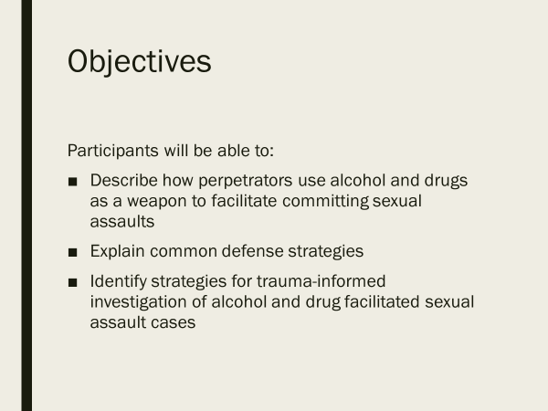  Note to Trainer: Slides 3-10 are the same as those slides in Module 6; use these if you have not recently conducted Module 6 with the same training participants.  Display Slide 3:  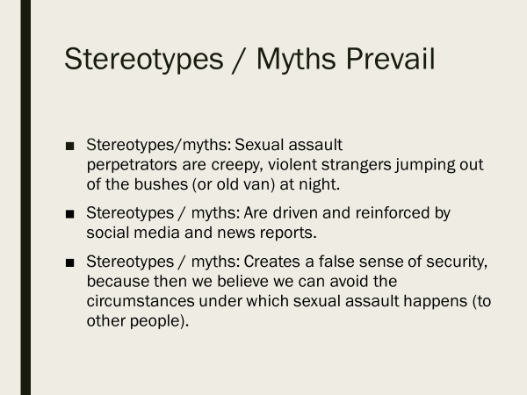  Display Slide 4:  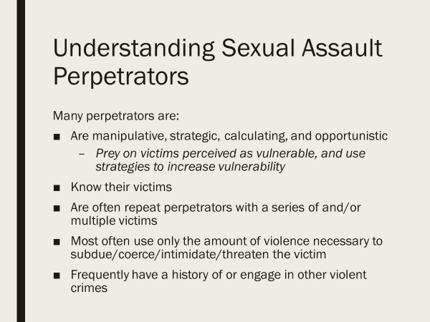  Display Slide 5:  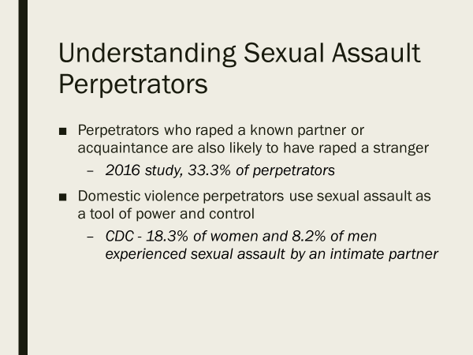  Display Slide 6:  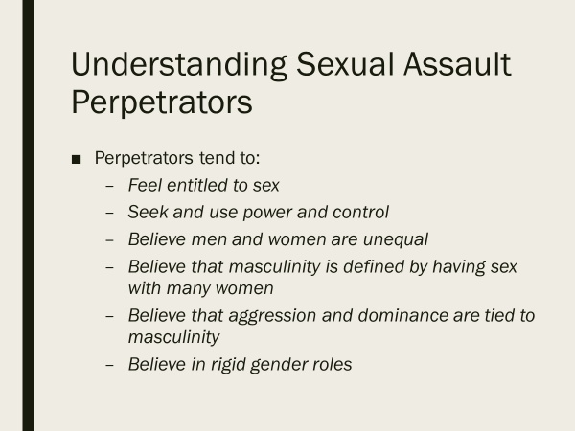  Display Slide 7:  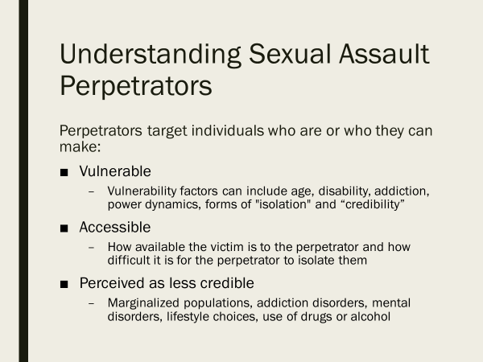  Display Slide 8:  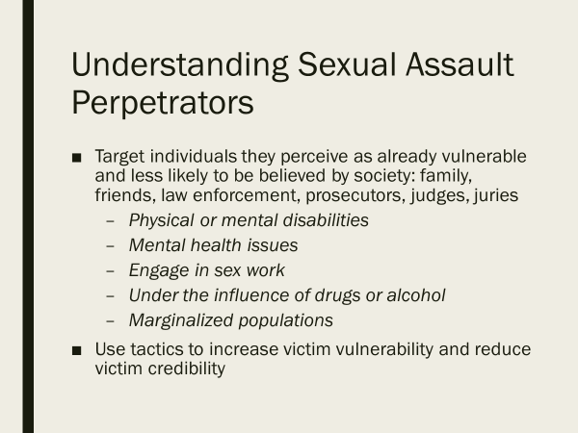  Note to Trainer: A few examples of cases that gained attention at the national level are the Daniel Holtzclaw, Sam Little, and Anthony Sowell cases. In these cases, the perpetrators primarily targeted individuals who were women of color who were further vulnerable and perceived as less credible as a result of socioeconomic status, substance use, and/or engagement in sex work. We encourage you to read/watch the resources in the endnote to become familiar with these cases.  Display Slide 9:  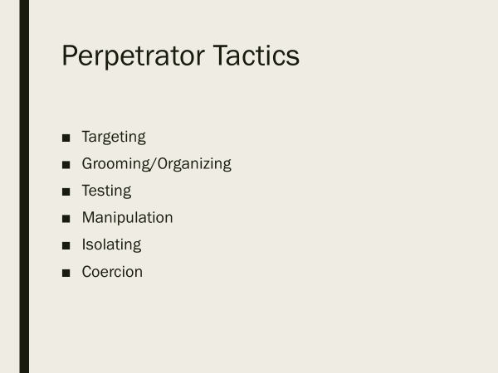  Note to Trainer: It is important to use a case that your agency investigated as the case study will resonate better with agency members and reinforce that perpetrators across demographics and regional areas share these characteristics. Additionally, you will have enough details to build a case study and be better equipped to answer participant questions.  Display Slide 10:  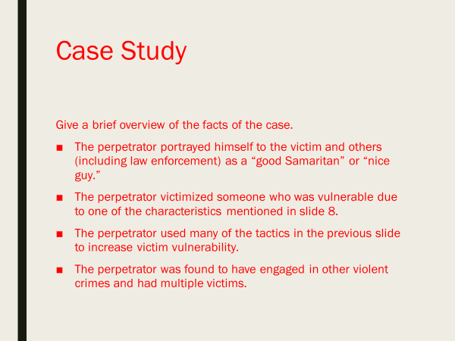  Display Slide 11:  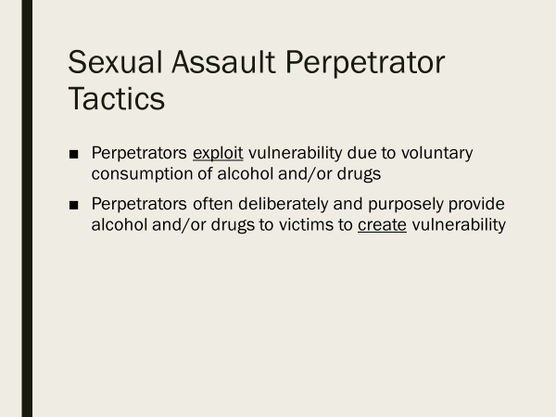  Display Slide 12:  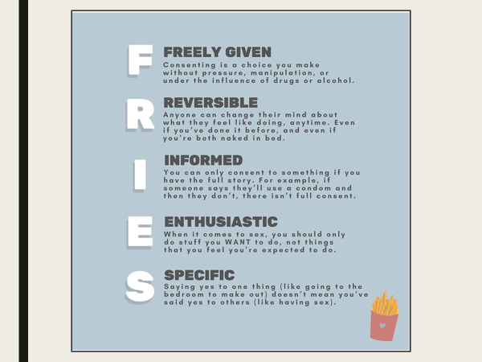  Display Slide 13:  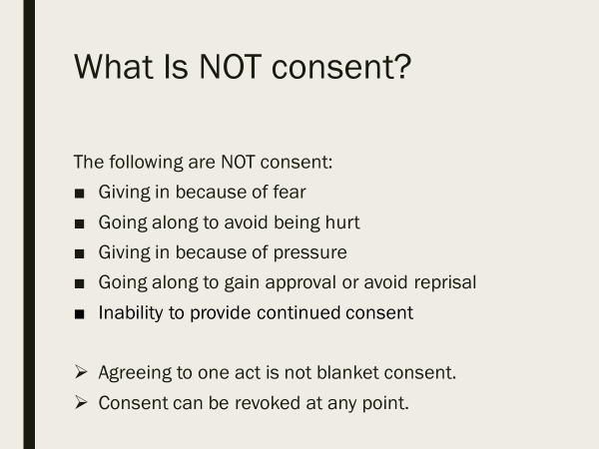  Display Slide 14:  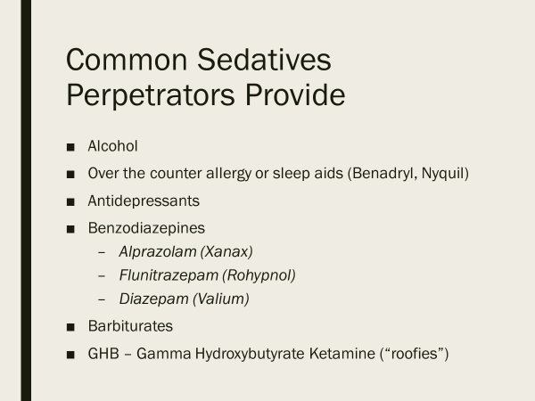  Display Slide 15:  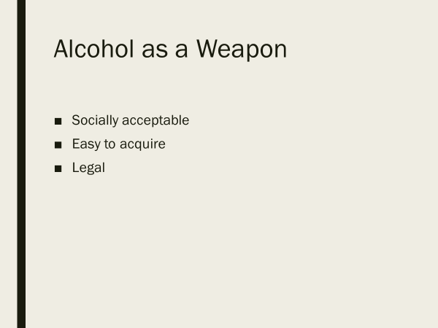  Display Slide 16:  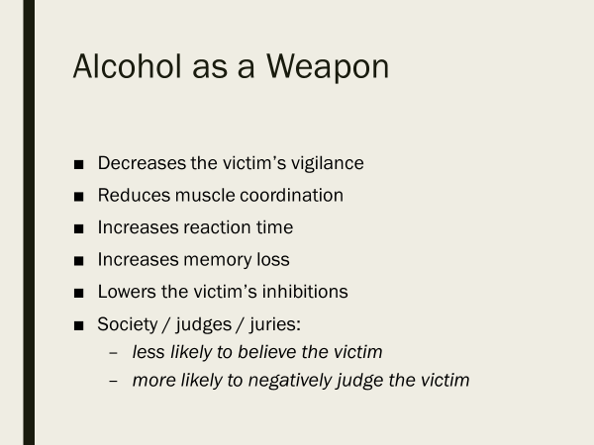  Display Slide 17:  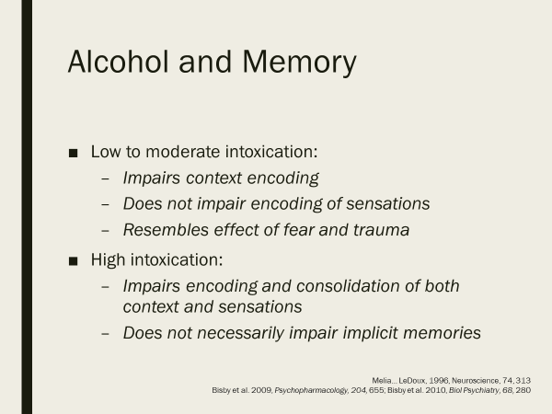  Display Slide 18:  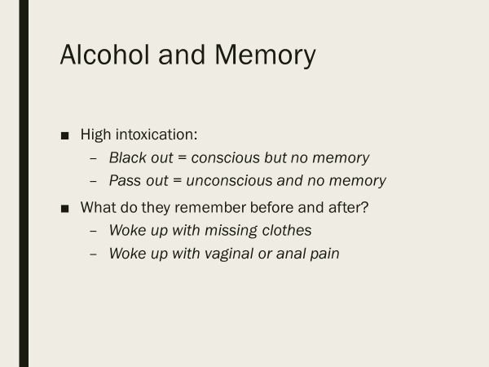  Display Slide 19:  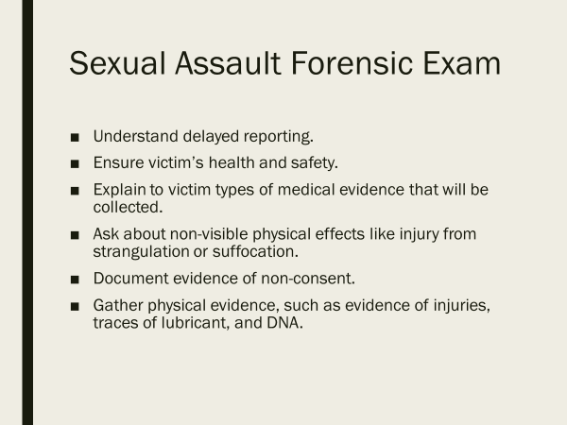  Display Slide 20:  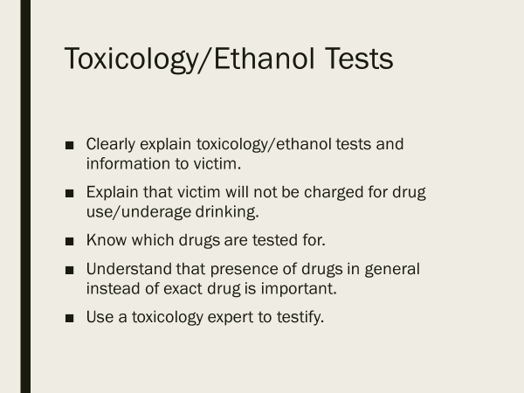  Display Slides 21 & 22:  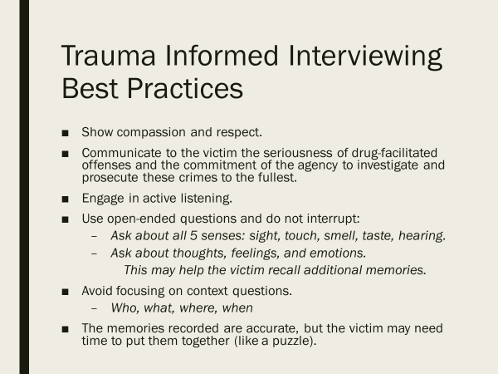  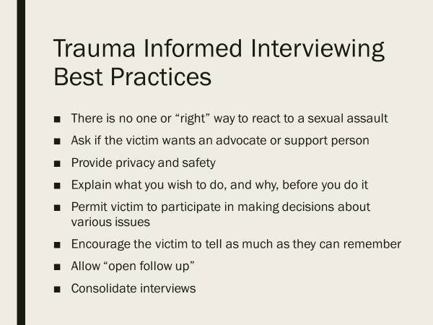  Display Slide 23:  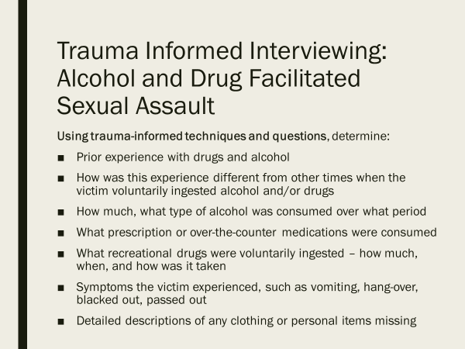  Display Slide 24:  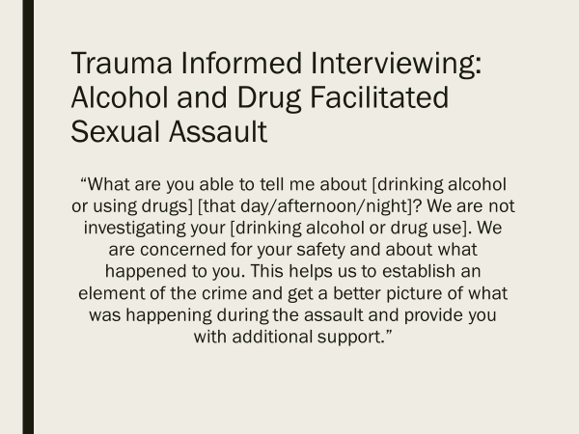  Display Slide 25:  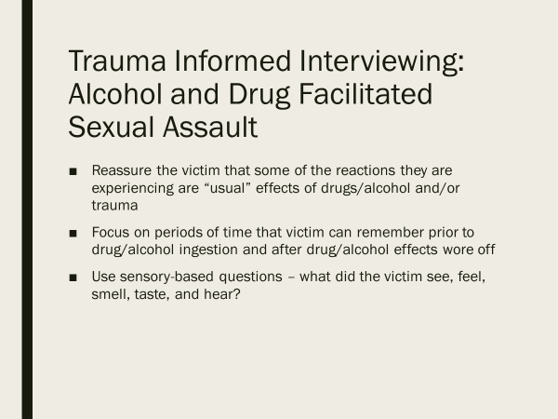  Display Slide 26:  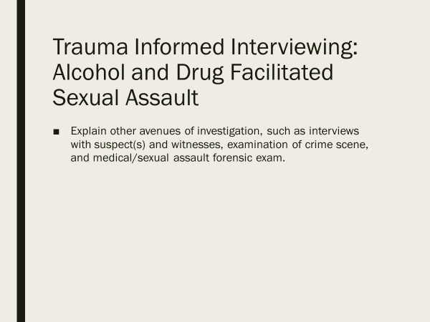  Display Slide 27:  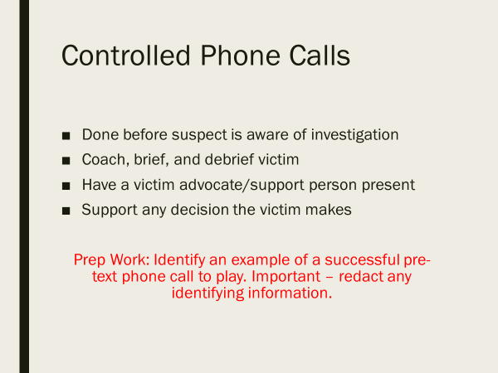  Display Slide 28:  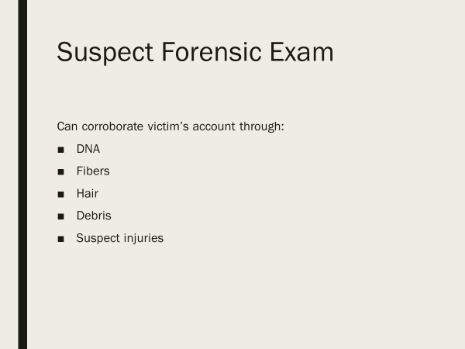  Display Slide 29:  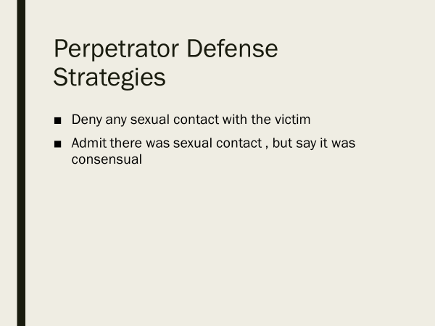  Display Slide 30:  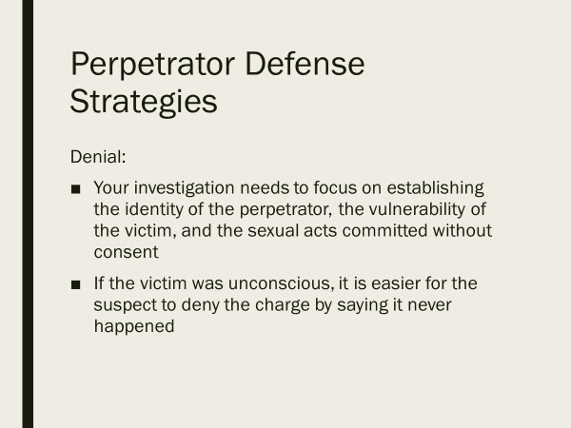  Display Slide 31:  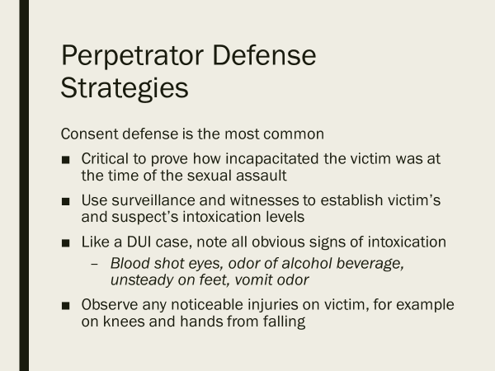  Display Slide 32:  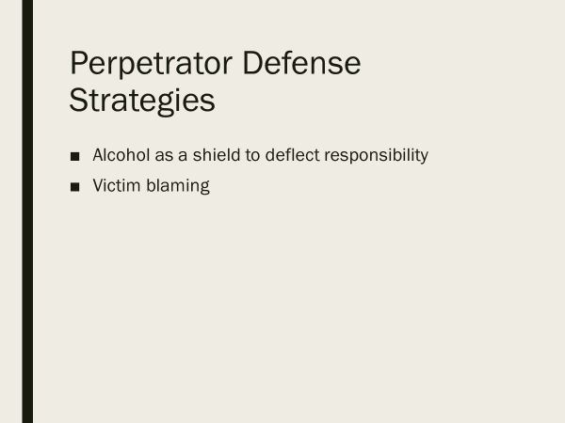  Display Slide 33:  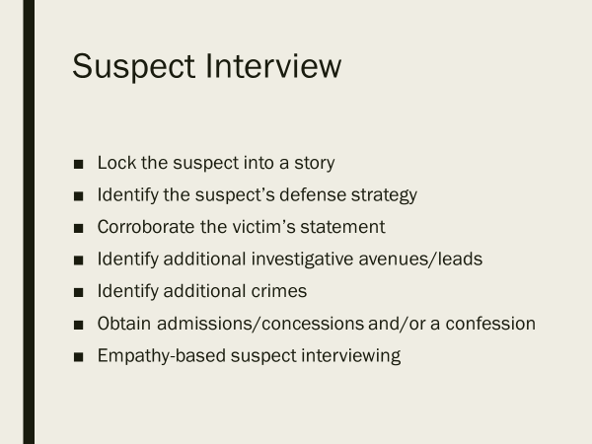  Display Slide 34:  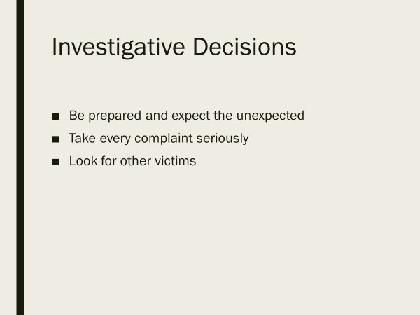  Display Slide 35:  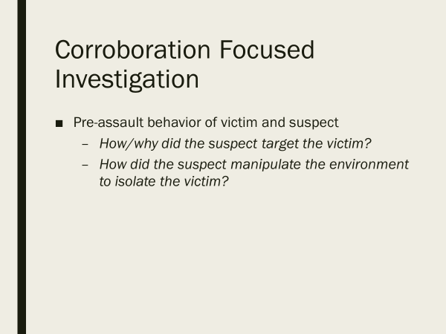  Display Slide 36:  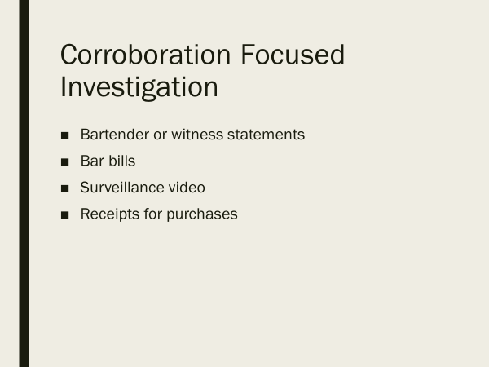  Display Slide 37:  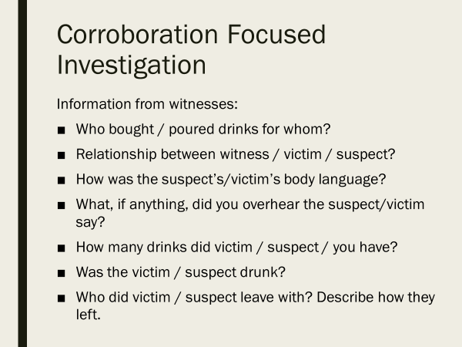  Display Slide 38:  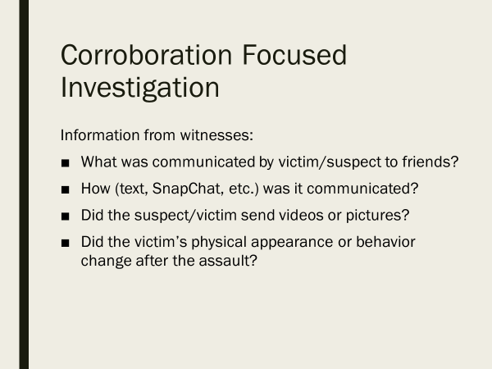  Display Slide 39:  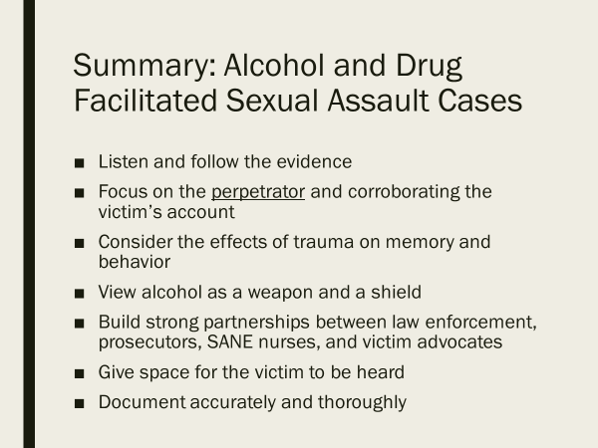

Sexual Assault Response Policy and Training Content Guidelines (Alexandria, VA: International Association of Chiefs of Police (IACP), 2017).
Sexual Assault Incident Reports: Investigative Strategies (Alexandria, VA: IACP, 2008).
Rachel Lovell, Fred Butcher, and Daniel Flannery, Cuyahoga County Sexual Assault Kit Pilot Project (SAK): Report on Serial and One-Time Sexual Offenders (Cleveland, OH: Begun Center for Violence Prevention Research and Education, Case Western Reserve University, March 2016).
Mike Milnor and Nancy Oglesby, “Empathy Based Suspect Interviewing – Part 1,” End Violence Against Women International, video, 1:30; Mike Milnor and Nancy Oglesby, “Empathy Based Suspect Interviewing – Part 2,” End Violence Against Women International, video, 1:30.
Herbert Tanner and Wendy Patrick, “Challenging Victims: The Delicate Dynamics of Drug & Alcohol Facilitated Sexual Assault Webinar,” End Violence Against Women International (EVAWI), video, 1:30.
Roger Canaff and Mike Milnor, “A Dangerous Defense: "Blackout" in Alcohol Facilitated, Non-Stranger Sexual Assault Cases Webinar,” EVAWI, video, 1:30.
Jennifer Long, Charlene Whitman-Barr, and Viktoria Kristiansson, Alcohol- and Drug-Facilitated Sexual Assault: A Survey of the Law, (Philadelphia, PA: AEquitas: The Prosecutor’s Resource on Violence Against Women, August 2016).
Jon Kurland and Patti Powers, “Alcohol-Facilitated Sexual Assault: Who Needs Force When You Have Alcohol Part 1,” AEquitas, video, 1:29:52; Jon Kurland and Patti Powers, “Alcohol-Facilitated Sexual Assault Part 2,” AEquitas, video, 1:30:50.
Rob Fanelli, “Drug and Alcohol Facilitated Sexual Assault (DFSB)”, video, The International Association of Chiefs of Police, 2021.
“Identifying Men Who Use Violence,” SAFER, Common Grace.
“Identifying Men Who Use Violence,” SAFER.
“Perpetrators of Sexual Violence: Statistics,” Rape, Abuse & Incest National Network (RAINN); “Non-Stranger Sexual Assault,” College of Saint Benedict–Saint John’s University, Counseling & Health Promotion & CSB Health Services; “The Neurobiology of Sexual Assault: Implications for Law Enforcement, Prosecution, and Victim Advocacy,” National Institute of Justice, December 1, 2012, video, 1:35:16; “Statistics,” National Coalition Against Domestic Violence; “Fact Sheet: Strangulation & Sexual Violence,” Pennsylvania Coalition Against Rape (PCAR); Allie Phillips, “Domestic Violence and Co-occurrence with Child Abuse and Neglect,” Prevent Child Abuse America, Resolution 11.14.02; Allie Phillips, Understanding the Link between Violence to Animals and People: A Guidebook for Criminal Justice Professionals (Alexandria, VA: National District Attorneys Association, 2014), 7; Sexual Assault Incident Reports; Lovell, Butcher, and Flannery, Cuyahoga County Sexual Assault Kit Pilot Project (SAK), 2.
Lovell, Butcher, and Flannery, Cuyahoga County Sexual Assault Kit Pilot Project (SAK).
Sharon Smith et al., The National Intimate Partner and Sexual Violence Survey: 2015 Data Brief – Updated Release (Atlanta, GA: National Center for Injury Prevention and Control, Centers for Disease Control and Prevention, 2018), 8-9.
Cheryl B. Preston, “Significant Bits and Pieces: Learning from Fashion Magazines about Violence against Women,” UCLA Women’s Law Journal 9, no. 1 (1998): 59–71.
Sexual Assault Response Policy and Training Content Guidelines, 29.
Sexual Assault Incident Reports, 8.
Sexual Assault Incident Reports, 8; Sexual Violence in Communities of Color (Harrisburg, PA: The Women of Color Network, Inc., 2016); Violence in LGBTQ Communities of Color (Harrisburg, PA: The Women of Color Network, 2016).
Sexual Assault Incident Reports, 7.
Smith et al., The National Intimate Partner and Sexual Violence Survey: 2015 Data Brief – Updated Release, 2; David Lisak and Paul Miller, “Repeat Rape and Multiple Offending Among Undetected Rapists,” Violence and Victims 17, no.1 (2002): 73–84; Antonia Abbey, Alcohol-Related Sexual Assault: A Common Problem among College Students, Journal of Studies on Alcohol, Suppl. 14 (March 2002): 118–128.
Long, Whitman-Barr, and Kristiansson, Alcohol- and Drug-Facilitated Sexual Assault; Kimberly Lonsway and Joanne Archambault, Preliminary Investigation: Guidelines for First Responders (Washington, DC: EVAWI, 2019), 37.
Sharon G. Smith, Xinjian Zhang, Kathleen C. Basile, Melissa T. Merrick, Jing Wang, Marcie-jo Kresnow, and Jieru Chen, The National Intimate Partner and Sexual Violence Survey: 2015 Data Brief – Updated Release (Washington, DC: Centers for Disease Control and Prevention, 2018), 2.
David Lisak and Paul Miller, “Repeat Rape and Multiple Offending Among Undetected Rapists”, Violence and Victims, 17, No.1 (2002): 73-84, accessed July 15, 2020.
Antonia Abbey, Alcohol-Related Sexual Assault: A Common Problem among College Students, J Stud Alcohol Suppl. 2002 Mar; (14): 118–128.
“So You Want to Talk About Consent,” soyouwanttotalkabout, Instagram post, July 8, 2020.
Sexual Assault Response Policy and Training Content Guidelines, (Alexandria, VA: International Association of Chiefs of Police (IACP), 2017), 19-20; Fanelli, “Drug and Alcohol Facilitated Sexual Assault (DFSB)”.
Sexual Assault Response Policy and Training Content Guidelines, IACP, 36.
Fanelli, “Drug and Alcohol Facilitated Sexual Assault (DFSB)”; Lonsway and Archambault, Preliminary Investigation: Guidelines for First Responders, 39.
Fanelli, “Drug and Alcohol Facilitated Sexual Assault (DFSB)”; Long, Whitman-Barr, and Kristiansson, Alcohol- and Drug-Facilitated Sexual Assault.
Fanelli, “Drug and Alcohol Facilitated Sexual Assault (DFSB)”; Lonsway and Archambault, Preliminary Investigation, 37-38.
Lonsway and Archambault, Preliminary Investigation, 39.
Kristin Little, A National Protocol for Sexual Assault Medical Forensic Examinations: Adults/Adolescents 2nd Edition (Washington, DC: U.S. Department of Justice, Office on Violence Against Women, 2013), 43-45.
Jennifer Markowitz, Absence of Anogenital Injury in the Adolescent/Adult Female Sexual Assault Patient, AEquitas: Strategies in Brief, no. 13 (2012).
Sexual Assault Response Policy and Training Content Guidelines, IACP, 17.
Sexual Assault Response Policy and Training Content Guidelines, IACP, 20 & 33-34; Fanelli, “Drug and Alcohol Facilitated Sexual Assault (DFSB)”.
IACP, Successful Trauma Informed Victim Interviewing (June 2020), 3.
Fanelli, “Drug and Alcohol Facilitated Sexual Assault (DFSB)”.
IACP, Successful Trauma Informed Victim Interviewing, 3; Fanelli, “Drug and Alcohol Facilitated Sexual Assault (DFSB)”; Sexual Assault Response Policy and Training Content Guidelines, IACP, 19-20; Lonsway and Archambault, Preliminary Investigation, 38.
Fanelli, “Drug and Alcohol Facilitated Sexual Assault (DFSB)”; Lonsway and Archambault, Preliminary Investigation, 37-38.
Fanelli, “Drug and Alcohol Facilitated Sexual Assault (DFSB)”.
IACP, Successful Trauma Informed Victim Interviewing, 3.
Fanelli, “Drug and Alcohol Facilitated Sexual Assault (DFSB)”; Lonsway and Archambault, Preliminary Investigation, 38.
IACP, Successful Trauma Informed Victim Interviewing, 2–4.
Fanelli, “Drug and Alcohol Facilitated Sexual Assault (DFSB)”.
“Suspect Examinations,” Office of Justice Programs, Office for Victims of Crime, accessed July 15, 2020; Sexual Assault Response Policy and Training Content Guidelines, IACP, 35.
Lonsway and Archambault, Preliminary Investigation, 15-16;
Fanelli, “Drug and Alcohol Facilitated Sexual Assault (DFSB)”.
Mike Milnor and Nancy Oglesby, “Empathy Based Suspect Interviewing – Part 1,” End Violence Against Women International, video, 1:30; Mike Milnor and Nancy Oglesby, “Empathy Based Suspect Interviewing – Part 2,” End Violence Against Women International, video, 1:30.
Milnor and Oglesby, “Empathy Based Suspect Interviewing – Part 1,”; Milnor and Oglesby, “Empathy Based Suspect Interviewing – Part 2”.
“Bringing Sexual Assault Offenders to Justice,” IACP, video, segment 3;
Sexual Assault Incident Reports, IACP, 7; Sexual Assault Incident Reports, IACP, 20-22.
Sexual Assault Incident Reports, IACP, 19-22; Fanelli, “Drug and Alcohol Facilitated Sexual Assault (DFSB)”.
Fanelli, “Drug and Alcohol Facilitated Sexual Assault (DFSB)”; Tanner and Patrick, “Challenging Victims: The Delicate Dynamics of Drug & Alcohol Facilitated Sexual Assault Webinar”; Canaff and Milnor, “A Dangerous Defense: "Blackout" in Alcohol Facilitated, Non-Stranger Sexual Assault Cases Webinar”.
Sexual Assault Incident Reports, IACP, 7; Sexual Assault Incident Reports, IACP, 19-22.
Susan Welsh et al., “How the Daniel Holtzclaw Jury Decided to Send the Ex-Oklahoma City Police Officer to Prison for 263 Years,” ABC News, May 20, 2016; Concepcion de Leon, “The Trial of Daniel Holtzclaw, the Cop Charged With Sexually Assaulting 13 Black Women,” Glamour, December 9, 2015; “Imperial Avenue Uncovered: The Victims,” The Cleveland Plain Dealer, YouTube video, 4:12; “Imperial Avenue Uncovered: The Suspect,” The Cleveland Plain Dealer, YouTube video, 9:29; “Samuel Little Biography,” Biography.com, updated April 7, 2020.

