May 25, 2023

Representative Morgan Griffith

U.S. House of Representatives

2202 Rayburn House Office Building

Washington, DC 20515

Dear Representative Griffith,

On behalf of the International Association of Chiefs of Police (IACP), I am writing to express our support for the Halt All Lethal Trafficking (HALT) of Fentanyl Act (H.R. 467).

As you know, this bill would permanently classify fentanyl and its analogs as a Schedule I substance under the Controlled Substances Act. The bill also establishes a new, alternative registration process for schedule I research that is funded by the Department of Health and Human Services or the Department of Veterans Affairs or that is conducted under an investigative new drug exemption from the Food and Drug Administration.

In a recently published report, the United States overdose deathrate involving fentanyl nearly quadrupled from 2016 to 2021[1]. Fentanyl poses a significant threat to law enforcement officers who may come in contact through routine law enforcement activities or even life-saving measures. Law enforcement and other first responders are unwittingly at risk of being exposed to illicit fentanyl while performing their duties. It is vital that Congress address the growing fentanyl overdose epidemic to protect the safety of law enforcement and communities that they serve.

I would like to thank you for your continuing commitment to enhancing public safety. The IACP stands ready to assist you as we continue to work together to advance the HALT Act and work on issues important to policing and our communities.

Sincerely,

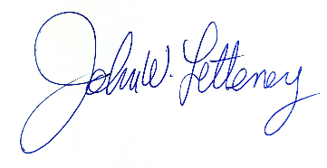

John W. Letteney

IACP President

1. https://www.axios.com/2023/05/03/fentanyl-overdose-death-rates-statistics