January 3, 2024

The Honorable Mike Johnson  Speaker  U.S. House of Representatives  Washington, D.C. 20515 | The Honorable Charles E. Schumer  Majority Leader  United States Senate  Washington, D.C. 20515

The Honorable Hakeem Jeffries The Honorable Mitch McConnell
Democratic Leader Minority Leader
U.S. House of Representatives United States Senate
Washington, DC 20515 Washington, DC 20515

Dear Speaker Johnson, Democratic Leader Jeffries, Majority Leader Schumer, and Minority Leader McConnell,

I am writing on behalf of The International Association of Chiefs of Police (IACP) to urge Congress to reauthorize the Undetectable Firearms Act (UFA) before it expires on February 2, 2024.

Originally enacted into law in 1988 and reauthorized three more times since then, the UFA makes it unlawful to manufacture, import, sell, ship, deliver, possess, transfer, or receive any firearms that cannot be detected by walk-through metal detectors or that have a major component that is not accurately shown when subjected to x-ray machines commonly used at airports. Without reauthorization of the UFA, public safety is at great risk since law enforcement rely on x-ray machines to protect airports, mass gatherings, and government buildings. If components of firearms are x-ray machine resistant, law enforcement cannot effectively provide security protection to the public and public engagements.

I would like to thank you for your continuing commitment to enhancing public safety. The IACP stands ready to assist you as we continue to work together to reauthorize the Undetectable Firearms Act and work on issues important to policing and our communities.

Sincerely,

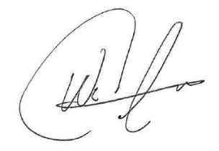
Wade Carpenter
IACP President

